Yearly schedule

PGY I

Every intern spends between 3-4 months on the general medical ward – divided between Jacobi and Weiler hospitals and 1.5-2 months in the specialty wards in Jacobi (Pulmonary, Oncology and ACS). The interns are also rotating between the CCU (Jacobi and Weiler hospitals) and in the MICU- total months in the units 2-2.5.
Each intern has 1-1.5 months of night float (divided to 2 weeks blocks) and 1 month of outpatient experience- usually divided into 2 blocks (2 weeks each) as well as continuity clinic once a week through the year where the interns get to know new patients that hopefully they will become their primary doctors for the 3 years of the their residency. The rest of the year includes 1 month of vacation that can be divided into two blocks and ED rotation and elective time (each one is 2 weeks).

 | Categorical (3 yr)  (months) | Preliminary (1 yr)  (months)
GM Wards | 3-4 | 3
MICU | 1 | 0.5-1
CCU (JCCU or WCCU) | 1 | 1.5
Night Float | 1-1.5 | 1.5
Special ward (Onc/Pulm/ACS) | 1.5-2 | 1.5–2
ED | 0.5 | 0.5
Elective | 0.5 | 1
Ambulatory | 1 | 1
Vacation | 1 | 1

PGY II

During 2nd year of residency the resident spend 1 month on the general medical wards and 1-2 months on the specialty wards. There are 2-3 months in the intensive care units
( Jacobi MICU, Jacobi and Weiler CCU). There are 1-1.5 months (divided to 2 weeks blocks of NF) and 1 block of day float.
In the 2nd year there are 2.5-3 months devoted to elective that can be a clinical or a research elective and can be done in Jacobi Medical Center or in any other clinical or research facility. There are 2 months of Ambulatory and the resident also continue to have once a week continuity clinic (also during elective time- unless it is out of Jacobi/Einstein setting).

Rotations | Months
General Medicine Wards | 1
Special wards | 1-2
JCCU/WCCU | 1-2
ICU | 1
Elective | 2.5-3
Ambulatory Care Rotation | 2
Day Float | 0-0.5
Night Float | 1-1.5
Vacation | 1

PGY III

As a third year our residents spend between 2-3 months on the general medicine wards (again JMC and Weiler). This year their role in the intensive care units is “unit chief” which is night shifts in the Jacobi MICU and JCCU- and they are the most senior physician in the units. Another 2-2.5 months are devoted to SMR (senior medical resident) in Jacobi and MAR (Medical Admitting rResident) in Wiler where they are the most senior resident who is responsible to triaging patients admitted from the ED to the medical wards and responsible to run all the codes during the shift

Rotations | Months
General Medicine Wards | 2-3
SMR/MAR | 2-2.5
ICU | 0-0.5
CCU | 1
Electives | 3.5
Ambulatory Care | 2
Vacation | 1

Specialty Wards

There are three medicine specialty wards in JMC where the house staff rotates through- Pulmonary, ACS and Oncology.
The teams on that wards consist of Attending (according to the subspecialty), one resident and two interns. The oncology team also includes an oncology fellow.
Theses rotations give the house staff an opportunity to deal in more depth with pt who suffer from a chronic lung disease, cancer or AIDS and it’s complications.

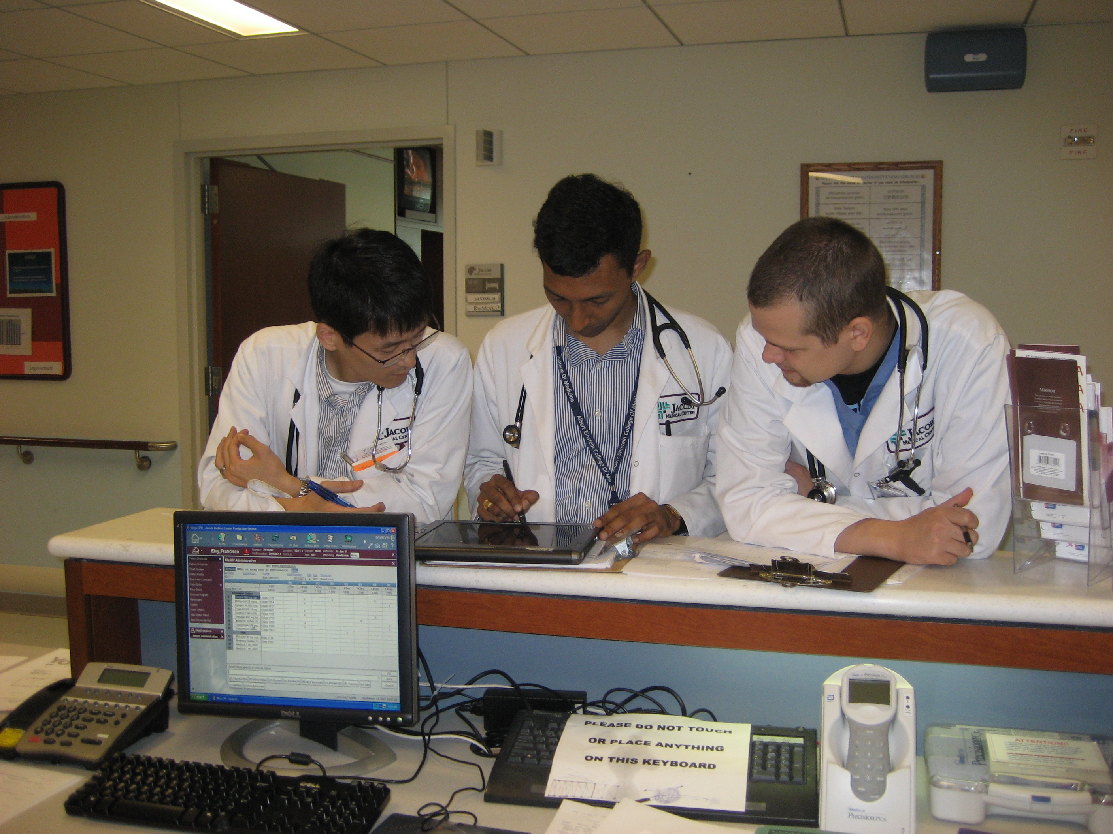

Intensive units rotations

Each intensive unit in Jacobi includes 12 monitored beds.
The CCU team includes a cardiology attending, cardiology fellow, 2 PGY II residents and 3 PGY I interns during the day and 1 PGY III (unit chief ) and 1 PGY I during the night. The CCU takes care of patients with ACS, decompensated CHF, cardiomyopathies etc.
The MICU team includes an intensive care attending, intensive care fellow, 3 PGY II resident and 3 PGY I interns during the day and 1 PGY III (unit chief) and 1 PGY I during night time. The MICU admits septic patients, ventilated pt that needs close monitoring, pt with sever intoxications, etc.

