DAILY INPATIENT SCHEDULE AT JMC

An inpatient team consists of one resident (PGY-2 or PGY-3), two interns, one sub-intern (a 4th year AECOM medical student), and two 3rd year AECOM medical students.

Intern Work Rounds – The intern gets sign out every morning @ 7AM from the covering Night Float intern. From 7-8AM, the intern is expected to see all of his patients and review vital signs and relevant labs.

Resident Work Rounds – The resident ‘walk’ rounds with the interns, sub-interns, and medical students.

Attending Rounds – The team rounds with the attending for 2-3 hours every morning and reviews new admissions as well as old cases. During these rounds, new patients are discussed in depth, journal articles related to patient care are reviewed, and teaching abounds.

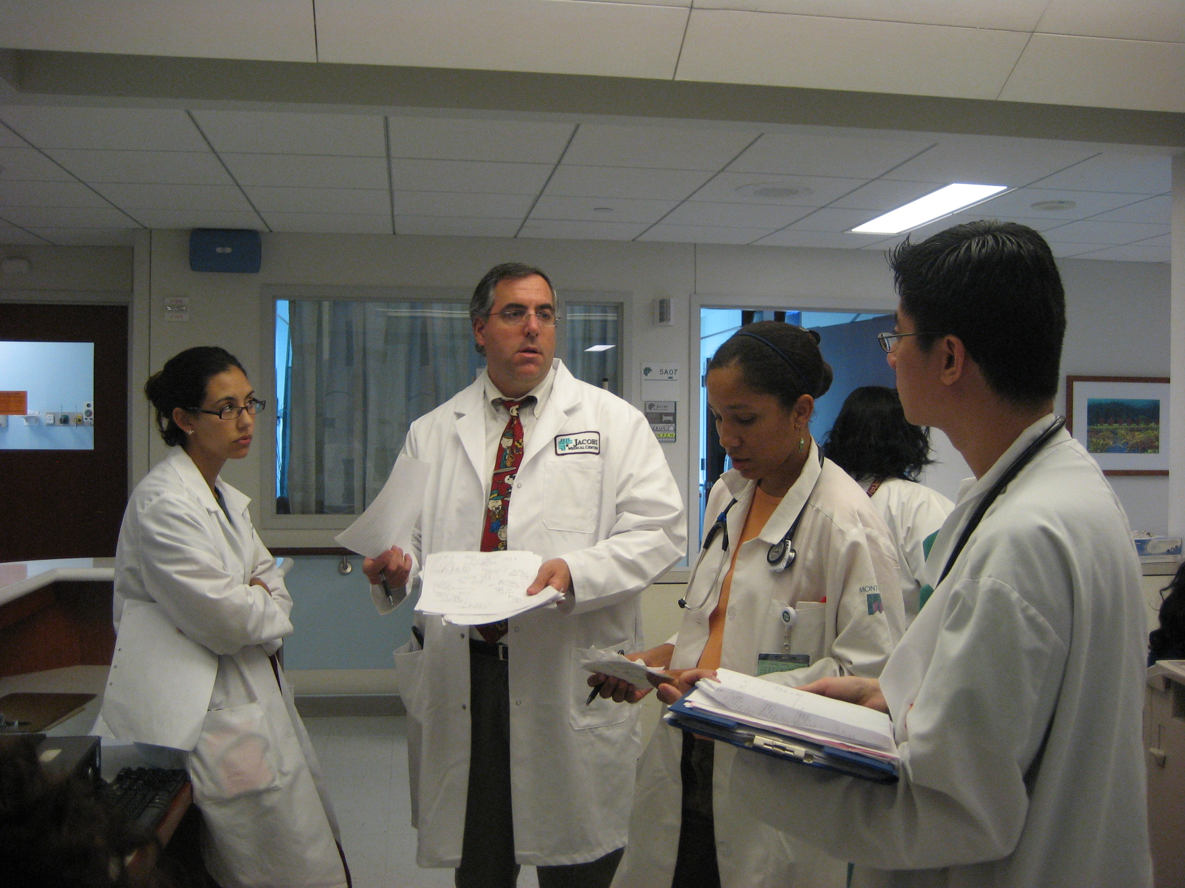

Social Work Rounds – Social work rounds are incorporated into attending rounds to expedite patient care and limit unnecessary hospital LOS. The social worker and case manager meet with the entire team and discuss potential discharges and social work related issues.

Resident Report – (PGY-2s and PGY-3s) - Unusual and challenging cases are presented to a senior attending with a particular focus on differential diagnosis and management issues. 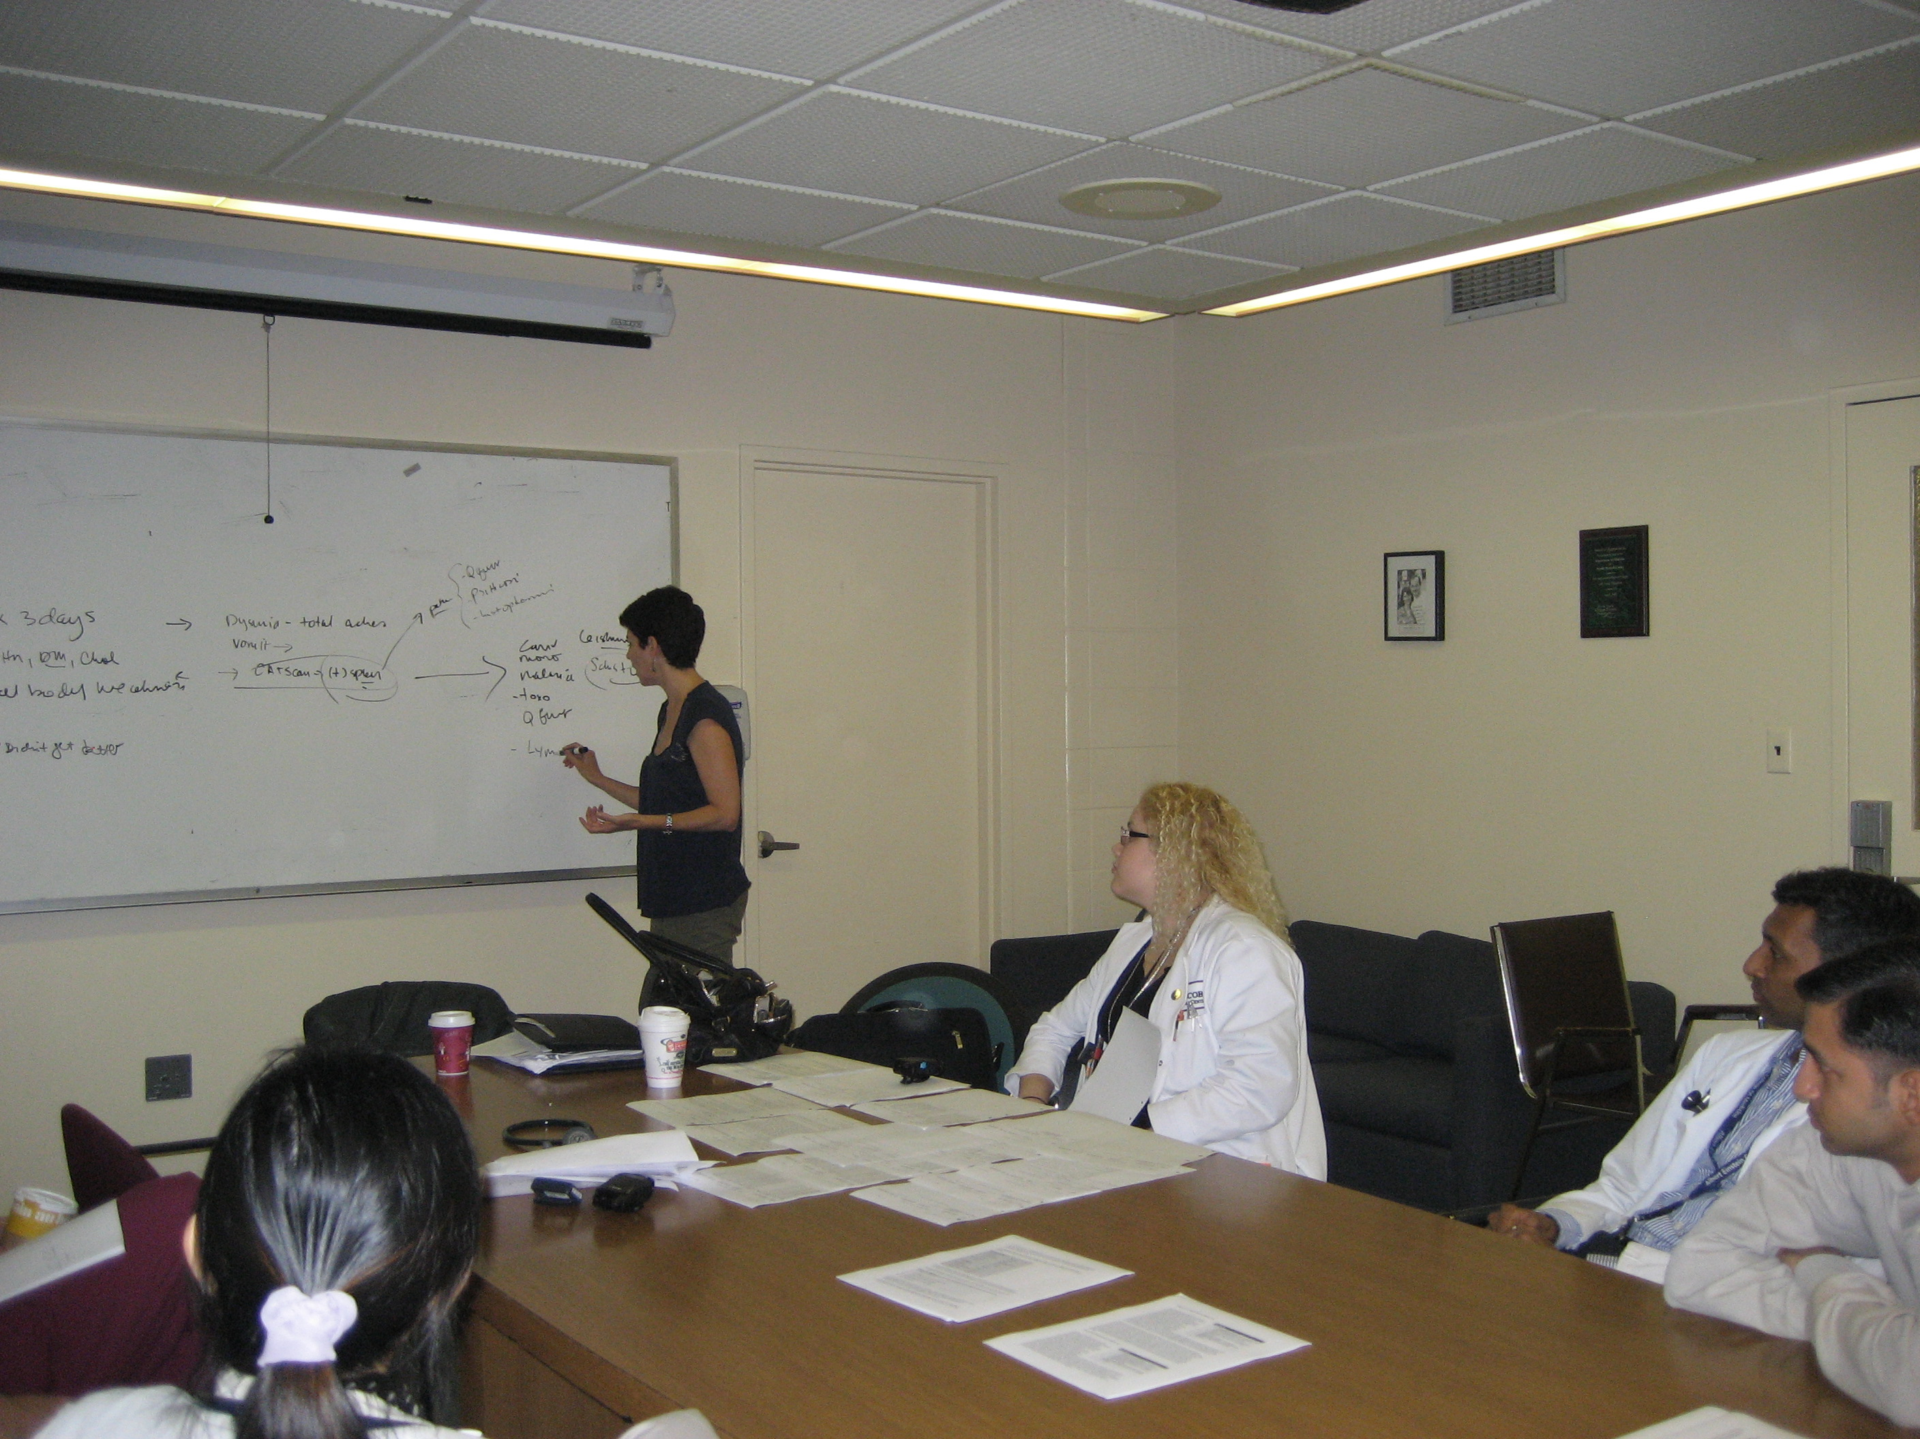

Clinical Questions (PGY-2s and PGY-3s) - Residents address a clinical question that arose related to patient care with a relevant journal article.

Boards Review (PGY-2s and PGY-3s) - Each week a subspecialist reviews IM subspecialty board questions, in preparation for the IM boards. Questions are distributed in advance for review to maximize the learning experience.

Noon Conference – Clinical lectures are given daily from 12:30-1:30. These conferences adhere to a rotating curriculum of the breadth of Internal Medicine as required by Residency oversight bodies.

Intern Conference - The interns meet with Dr. Susan Dresdner, Associate Program Director, and review interesting cases and journal articles. Intern related issues are discussed at length.

Journal Club - One floor resident selects a journal article, distributes it, and reviews it in depth with the other residents. Journal Club is moderated by Dr. Steve Martin, the IM Program Director, who has extensive knowledge and experience in EBM. The goal of Journal Club is to fine tune the residents’ EBM application skills. Concurrently interns have their own journal club, designed and run in a similar fashion.

Chief of Service – A particularly fascinating or difficult case is presented to the Chairman of the Medicine Dept or the Program Director.

Wards daily schedule (interns)

 | Monday | Tuesday | Wednesday | Thursday | Friday
7:00-8:00 | Board pick-up and pre-round | Board pick-up and pre-round | Board pick-up and pre-round | Board pick-up and pre-round | Board pick-up and pre-round
8:00-9:00 | Resident rounds/work rounds | Resident rounds/work rounds | Resident rounds/work rounds | Resident rounds/work rounds | Resident rounds/work rounds
9:00-11:00 | Attending rounds | Attending rounds | Attending rounds | Attending rounds | Attending rounds
11:00-12:30 | In-Patient Care | In-Patient Care | In-Patient Care | In-Patient Care | In-Patient Care
12:30-1:30 | Noon conference | Intern Conference | Noon conference | Noon conference- Chief of service | Noon conference/Grand Rounds
1:30-5:00 | In-Patient Care  Continuity clinic once a week | In-Patient Care  Continuity clinic once a week | In-Patient Care  Continuity clinic once a week | In-Patient Care  Continuity clinic once a week | In-Patient Care  Continuity clinic once a week
5:00 | Sign out to “on call team” | Sign out to “on call team” | Sign out to “on call team” | Sign out to “on call team” | Sign out to “on call team”

Wards daily schedule (residents)

 | Monday | Tuesday | Wednesday | Thursday | Friday
7:15-8:00 | Intake rounds | Intake rounds | Intake rounds | Intake rounds | Intake rounds
8:00-9:00 | Resident walking rounds/work rounds | Resident walking rounds/work rounds | Resident walking rounds/work rounds | Resident walking rounds/work rounds | Resident walking rounds/work rounds
9:00-11:00 | Attending rounds | Attending rounds | Attending rounds | Attending rounds | Attending rounds
11:00-12:00 | Resident report- Clinical Questions | Resident Report | Resident Report | Board Review questions | Resident Report
12:30-1:30 | Noon conference | Journal Club | Noon conference | Noon conference- Chief of service | Noon conference
1:30-5:00 | In-Patient Care  Continuity clinic once a week | In-Patient Care  Continuity clinic once a week | In-Patient Care  Continuity clinic once a week | In-Patient Care  Continuity clinic once a week | In-Patient Care  Continuity clinic once a week
4:30-5:00 | Evening (sitting) rounds prior to sign out | Evening (sitting) rounds prior to sign out | Evening (sitting) rounds prior to sign out | Evening (sitting) rounds prior to sign out | Evening (sitting) rounds prior to sign out

